

***Designing the User Interface:***

***Strategies for Effective Human-Computer Interaction***

***Fifth Edition***

**Ben Shneiderman & Catherine Plaisant**

***in collaboration with***

**Maxine S. Cohen and Steven M. Jacobs**

**Addison Wesley**

is an imprint of

© 2010 Pearson Addison-Wesley. All rights reserved.

CHAPTER 1:

Usability of Interactive Systems

1



**Introduction**

* **Human**–**Computer Interaction** (commonly referred to as **HCI**) is a discipline concerned with the study, design, construction and implementation of human centric interactive computer systems.
* The Interdisciplinary Design Science of Human- Computer Interaction (HCI) combines knowledge and methods associated with professionals including:
  + Psychologists (incl. Experimental, Educational, Social and Industrial Psychologists)
  + Computer Scientists
  + Instructional and Graphic Designers
  + Technical Writers
  + Human Factors and Ergonomics Experts
  + Anthropologists and Sociologists

© 2010 Pearson Addison-Wesley. All rights reserved.

1-2

2



**Usability goals & measures**

* **Usability Goals** — *effectiveness, efficiency, satisfaction*
* **Usability Measures** lead more directly to practical evaluation:

– Time to learn

How long does it take for typical members of the community to learn relevant task?

* + Speed of performance

How long does it take to perform relevant benchmarks?

* + Rate of errors by users

How many and what kinds of errors are made during benchmark tasks?

* + Retention over time

Frequency of use and ease of learning help make for better user retention

* + Subjective satisfaction

Allow for user feedback via interviews, free-form comments and satisfaction scales

© 2010 Pearson Addison-Wesley. All rights reserved.

1-3

3



**Usability motivations**

* **Life-critical systems:**
  + Air traffic control, nuclear reactors, power utilities, police & fire dispatch systems, medical equipment
  + High costs, reliability and effectiveness are expected
  + Length training periods are acceptable despite the financial cost to provide error-free performance and avoid the low frequency but high cost errors
  + Subject satisfaction is less an issue due to well motivated users

© 2010 Pearson Addison-Wesley. All rights reserved.

1-4

4



**Usability motivations (cont.)**

* **Industrial and commercial uses**
  + Banking, insurance, order entry, inventory management, reservation, billing, and point-of-sales systems
  + Ease of learning is important to reduce training costs
  + Speed and error rates are relative to cost
  + Speed of performance is important because of the number of transactions
  + Subjective satisfaction is fairly important to limit operator burnout

© 2010 Pearson Addison-Wesley. All rights reserved.

1-5

5

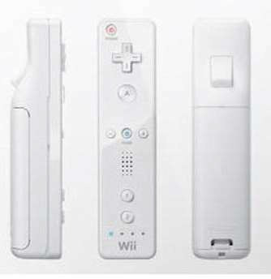

**Usability motivations (cont.)**

* **Office, home, and entertainment applications**
  + Word processing, electronic mail, computer conferencing, and video game systems, educational packages, search engines, mobile device, etc.
  + Ease of learning, low error rates, and subjective satisfaction are paramount due to use is often discretionary and competition fierce
  + Infrequent use of some applications means interfaces must be intuitive and easy to use online help is important
  + Choosing functionality is difficult because the population has a wide range of both novice and expert users
  + Competition cause the need for low cost

© 2010 Pearson Addison-Wesley. All rights reserved.

1-6

6



**Usability motivations (cont.)**

* **Exploratory, creative, and collaborative systems**
  + Web browsing, search engines, artist toolkits, architectural design, software development, music composition, and scientific modeling systems
  + Collaborative work
  + Benchmarks are hard to describe for exploratory tasks and device users
  + With these applications, the computer should be transparent so that the user can be absorbed in their task domain

© 2010 Pearson Addison-Wesley. All rights reserved.

1-7

7



**Usability motivations (cont.)**

* **Social-technical systems**
  + Complex systems that involve many people over long time periods
  + Voting, health support, identity verification, crime reporting
  + Trust, privacy, responsibility, and security are issues
  + Verifiable sources and status feedback are important
  + Ease of learning for novices and feedback to build trust
  + Administrators need tools to detect unusual patterns of usage

© 2010 Pearson Addison-Wesley. All rights reserved.

1-8

8



**Cognitive and perceptual abilities**

* The human ability to interpret sensory input rapidly and to initiate complex actions makes modern computer systems possible.
* **Human cognitive processes:**
  + Long-term and semantic memory
  + Short-term and working memory
  + Problem solving and reasoning
  + Decision making and risk assessment
  + Language communication and comprehension
  + Search, imagery, and sensory memory
  + Learning, skill development, knowledge acquisition, and concept attainment

© 2010 Pearson Addison-Wesley. All rights reserved.

1-9

9



**Personality differences**

* Carl **Jung's theories of personality types**.
  + **Extroversion versus introversion**. Extroverts focus on external stimuli and like variety and action, whereas introverts prefer familiar patterns, rely on their inner ideas, and work alone contentedly.
  + **Sensing versus intuition**. Sensing types are attracted to established routines, are good at precise work, and enjoy applying known skills, whereas intuitive types like solving new problems and discovering new relations but dislike taking time for precision.
  + **Perceptive versus judging**. Perceptive types like to learn about new situations but may have trouble making decisions, whereas judging types like to make a careful plan and will seek to carry through the plan even if new facts change the goal.
  + **Feeling versus thinking**. Feeling types are aware of other people's feelings, seek to please others, and relate well to most people, whereas thinking types are unemotional, may treat people impersonally, and like to put things in logical order.

© 2010 Pearson Addison-Wesley. All rights reserved.

1-10

10



**Cultural and international diversity**

* Characters, numerals, special characters
* Left-to-right versus right-to-left versus vertical input and reading
* Date and time formats
* Numeric and currency formats
* Weights and measures
* Telephone numbers and addresses
* Names and titles (Mr., Ms., Mme.)
* Social-security, national identification, and passport numbers
* Capitalization and punctuation
* Sorting sequences
* Icons, buttons, colors
* Pluralization, grammar, spelling
* Etiquette, policies, tone, formality, metaphors

© 2010 Pearson Addison-Wesley. All rights reserved.

1-11

11



**Universal Usability**

* **Users with Disabilities**

– The flexibility of desktop, web, and mobile devices make it possible for designers to provide special services to users who have disabilities

* **Older Adult Users**

– Understanding the human factors of aging can help designers to create user interfaces that facilitate access by older adult users.

© 2010 Pearson Addison-Wesley. All rights reserved.

1-12

12



**Universal Usability**

* **Younger users**
  + Another lively community of users is children, whose uses emphasize entertainment and education.
  + When they become teenagers, they may become highly proficient users who often help their parents or other adults.
  + They are often frustrated with the use of technology and are endangered by threats surrounding privacy, alienation, pornography, unhelpful peers, and malevolent strangers.

© 2010 Pearson Addison-Wesley. All rights reserved.

1-13

13



**Goals for our profession**

* Potential research topics
* Providing tools, techniques, and knowledge for system implementers
* Raising the computer consciousness of the general public

© 2010 Pearson Addison-Wesley. All rights reserved.

1-14

14



***Designing the User Interface:***

***Strategies for Effective Human-Computer Interaction***

***Fifth Edition***

**Ben Shneiderman & Catherine Plaisant**

***in collaboration with***

**Maxine S. Cohen and Steven M. Jacobs**

**Addison Wesley**

is an imprint of

© 2010 Pearson Addison-Wesley. All rights reserved.

CHAPTER 2:

Guidelines, Principles, and Theories

15



**Guidelines, Principles, and Theories**

User-interface designers have accumulated a wealth of experience and researchers have produced a growing body of empirical evidence and theories, all of which can be organized into:

* Specific and practical **guidelines** that prescribe good practices and caution against dangers.
* Middle-level **principles** to analyze and compare design alternatives.
* High-level **theories** and models that describe objects and actions with consistent terminology so that comprehensible explanations can be made to support communication and teaching.

© 2010 Pearson Addison-Wesley. All rights reserved.

16



**Guidelines**

* A guidelines document helps by developing a shared language and then promoting consistency among multiple designers in terminology usage, appearance, and action sequences.
* It records **best practices** derived from practical experience or empirical studies, with appropriate examples and counter examples.
* Critics: Too specific, incomplete, hard to apply, and sometimes wrong

© 2010 Pearson Addison-Wesley. All rights reserved.

17

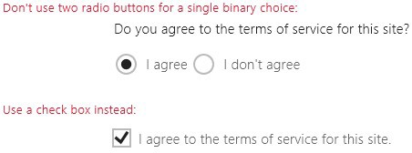

**Guidelines for Navigating the interface**

* Standardize task sequences
* Use thumbnails to preview large images
* Ensure that embedded links are descriptive
* Use unique and descriptive headings
* Use check boxes for binary choices

© 2010 Pearson Addison-Wesley. All rights reserved.

2-18

18



**Accessibility guidelines**

* **Text alternatives**. Provide text alternatives for any non-text content so that it can be changed into other forms people need, such as large print, braille, speech, symbols, or simpler language.
* **Time-based media**. Provide alternatives for time-based media (e.g., movies or animations). Synchronize equivalent alternatives (such as captions or auditory descriptions of the visual track) with the presentation.
* **Distinguishable**. Make it easier for users to see and hear content, including separating foreground from background. Color is not used as the only visual means of conveying information, indicating an action, prompting a response, or distinguishing a visual element.
* **Predictable**. Make web pages appear and operate in predictable ways.

© 2010 Pearson Addison-Wesley. All rights reserved.

2-19

19

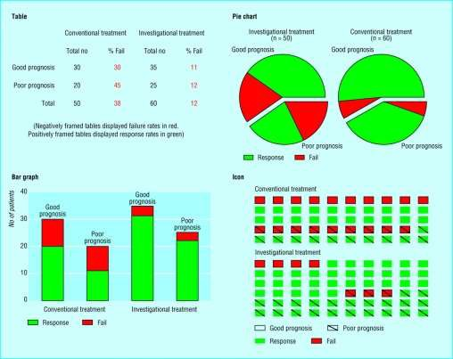

**Organizing the display**

* Consistency of data display
* Efficient information assimilation by the user
* Minimal memory load on the user
* Compatibility of data display with data entry
* Flexibility for user control of data display

© 2010 Pearson Addison-Wesley. All rights reserved.

2-20

20



**Getting the user's attention**

These guidelines detail several techniques for getting the user's attention:

* *Intensity*. Use two levels only, with limited use of high intensity to draw attention.
* *Marking*. Underline the item, enclose it in a box, point to it with an arrow, or use an indicator such as an asterisk, bullet, dash, plus sign, or X.
* *Size*. Use up to four sizes, with larger sizes attracting more attention.
* *Choice of fonts*. Use up to three fonts.
* *Inverse video*. Use inverse coloring.
* *Blinking*. Use blinking displays (2-4 Hz) or blinking color changes with great care and in limited areas.
* *Color*. Use up to four standard colors, with additional colors reserved for occasional use.
* *Audio*. Use soft tones for regular positive feedback and harsh sounds for rare emergency conditions.

© 2010 Pearson Addison-Wesley. All rights reserved.

2-21

21



**Principles**

* More fundamental, widely applicable, and enduring than guidelines
* Need more clarification/interpretation
* Fundamental principles
  + Determine user’s skill levels
  + Identify the tasks

© 2010 Pearson Addison-Wesley. All rights reserved.

2-22

22



**Determine user’s skill levels**

**Design goals based on skill level:**

* ***Novice or first-time users***. True novice users—for example, grandparents sending their first e-mail to a grandchild—are assumed to know little of the task or interface concepts. By contrast, first-time users are often professionals who know the task concepts well but have shallow knowledge of the interface concepts.
* ***Knowledgeable intermittent users***. Many people are knowledgeable but intermittent users of a variety of systems (for example, corporate managers using word processors to create templates for travel reimbursements).
* ***Expert frequent users***. Expert "power" users are thoroughly familiar with the task and interface concepts and seek to get their work done quickly.

© 2010 Pearson Addison-Wesley. All rights reserved.

2-23

23



**Identify the tasks**

* After carefully drawing the user profile, the developers must identify the tasks to be carried out.
* Every designer would agree that the set of tasks must be determined before design can proceed, but too often, the task analysis is done informally or incompletely.
* High-level task actions can be decomposed into multiple middle-level task actions, which can be further refined into atomic actions that users execute with a single command, menu selection, or other action.

© 2010 Pearson Addison-Wesley. All rights reserved.

2-24

24

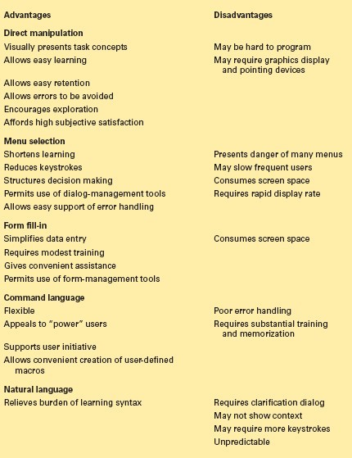

**Interaction styles**

1. Direct Manipulation
2. Menu selection
3. Form fill-in
4. Command language
5. Natural language

**Refer the book for description**

© 2010 Pearson Addison-Wesley. All rights reserved.

2-25

25



**Schneiderman’s 8 golden rules of interface design**

1. Strive for consistency
2. Cater to universal usability
3. Offer informative feedback
4. Design dialogs to yield closure
5. Prevent errors
6. Permit easy reversal of actions
7. Support internal locus of control
8. Reduce short term memory load

**Refer the book for description**

© 2010 Pearson Addison-Wesley. All rights reserved.

2-26

26



**Theories**

* Beyond the specifics of guidelines
* Principles are used to develop reliable, broadly useful theories
* Theories – descriptive, explanatory prescriptive or predictive
* Theories concern: motor, perceptual, or cognitive skills

© 2010 Pearson Addison-Wesley. All rights reserved.

2-27

27



**More on theories**

* **Descriptive theories**
  + provide consistent terminology
* **Explanatory theories:**
  + Observing behavior
  + Describing sequence of activities
  + Conceiving of designs
  + Comparing high-level concepts of designs
* **Prescriptive theories:**
  + Giving designers clear guidance for choices
* **Predictive theories:**
  + Enable designers to compare proposed designs for

© 2010 Pearson Addison-Wesley. All rights reserved.

execution time or error rates

2-28

28



**Theories are according to Perceptual, Cognitive, & Motor Skills**

Another way to group theories is according to the types of skills involved:

* ***Motor skill performance theories*** are well established and accurate for predicting key stroking or pointing times.
* ***Perceptual theories*** have been successful in predicting reading times for free text, lists, formatted displays, and other visual or auditory tasks.
* ***Cognitive theories***, involving short term, working, and long- term memory, are central to problem solving and play a key role in understanding productivity as a function of response time.

© 2010 Pearson Addison-Wesley. All rights reserved.

2-29

29



**Design-by-Levels**

One approach to developing descriptive theories is to separate concepts according to levels.

* **The conceptual level** is the user's "mental model" of the interactive system.
* **The semantic level** describes the meanings conveyed by the user's input and by the computer's output display.
* **The syntactic level** defines how the user actions that convey semantics are assembled into complete sentences that instruct the computer to perform certain tasks.
* **The lexical level** deals with device dependencies and with the precise mechanisms by which users specify the syntax.

© 2010 Pearson Addison-Wesley. All rights reserved.

2-30

30



**Consistency**

* An important goal for designers is a consistent user interface.
* Consistency for objects and actions/commands
* Consistent use of color, layout, icons, fonts, button sizes etc.
* If terminology for objects and actions is orderly and describable by few rules, users will be able to learn and retain them easily.

© 2010 Pearson Addison-Wesley. All rights reserved.

2-31

31



**Consistency**

* This example illustrates consistency and two kinds of inconsistency (A illustrates lack of consistency, and B shows consistency except for a single violation):

delete/insert table

delete/insert table

delete/insert table

delete/insert column

remove/add column

remove/insert column

delete/insert row destroy/create row delete/insert row

delete/insert border

erase/draw border

delete/insert border

© 2010 Pearson Addison-Wesley. All rights reserved.

2-32

Each of the actions in the consistent version is the same, whereas the actions vary for inconsistent version A.

The inconsistent action verbs are all acceptable, but their variety suggests that they will take longer to learn, will cause more errors, will slow down users, and will be harder for users to remember.

Inconsistent version B is somehow more startling, because there is a single unpredictable inconsistency; it stands out so dramatically that this language is likely to be remembered for its peculiar inconsistency.

**Consistent Inconsistent A Inconsistent B**

32



***Designing the User Interface:***

***Strategies for Effective Human-Computer Interaction***

***Fifth Edition***

**Addison Wesley**

is an imprint of

**Ben Shneiderman & Catherine Plaisant**

***in collaboration with***

**Maxine S. Cohen and Steven M. Jacobs**

© 2010 Pearson Addison-Wesley. All rights reserved.

CHAPTER 3:

Direct Manipulation

33



**Introduction**

**Good interfaces => Satisfied user**

* Competence in performing tasks
* Ease in learning originally and in assimilating advanced features
* Confidence in the capacity to retain mastery over time
* Enjoyment in using the interface
* Eagerness to show off the interface to novices
* Desire to explore more powerful aspects

**Direct-manipulation interfaces => Good interfaces**

* + Visible objects
  + Rapid, reversible, incremental actions
  + Pointing actions

© 2010 Pearson Addison-Wesley. All rights reserved.

6-34

34



**Introduction**

* **Newer concepts extend direct manipulation Include**

– Collaborative interfaces

* + Touchable interfaces
  + Virtual reality
  + Augmented reality
  + Teleoperation

© 2010 Pearson Addison-Wesley. All rights reserved.

6-35

35



**Examples of Direct-Manipulation Systems**

* Spatial Data Management System

– Video Games

* Computer Aided Design

© 2010 Pearson Addison-Wesley. All rights reserved.

6-36

36



**Direct-Manipulation Systems :**

**Spatial data management**

* In geographic applications, it seems natural to give a spatial representation in the form of a map that provides a familiar model of reality.
* Xeroc PARC’s Information Visualizer : Tools for three-dimensional animated explorations of buildings, cone-shaped file directories, organization charts, a perspective wall that puts f atured items up front and centered, and several two- and three-dimensional information layouts.
* ArcGIS™ by ESRI™is a widely used geographic-information system (GIS) that offers rich, layered databases of map-related information
* GoogleMaps™and the more powerful Google Earth™ combines geographic information from aerial photographs, satellite imagery, and other sources to create a database of graphical information that can easily be viewed and displayed.

© 2010 Pearson Addison-Wesley. All rights reserved.

6-37

37



**Direct-Manipulation Systems :**

**Video Games**

* Most exciting, well-engineered, and commercially successful example of direct-manipulation systems → Video Games
* Pong first video game
* Nintendo Wii, Sony PlayStation, and Microsoft Xbox continue to evolve
  + 3D, stereo sound, multiplayer, wireless controllers
  + Commands are physical actions whose results are immediately shown on screen
  + No syntax to remember → no syntax error messages
  + Games continuously display a score → feedback encourages mastery

© 2010 Pearson Addison-Wesley. All rights reserved.

6-38

38



**Direct-Manipulation Systems**

* **Game Examples:**
  + SimCity – good example of direct manipulation / urban planning

– Second Life – social virtual world

* + Spore – evolving creatures
  + Myst – puzzle; well received
  + DOOM and Quake controversial
  + World of Warcraft – massive multiplayer game
  + *Guitar Hero* video game

© 2010 Pearson Addison-Wesley. All rights reserved.

6-39

39



**Direct-Manipulation Systems :**

**Computer-aided design**

* Most computer-aided design (CAD) systems for automobiles, electronic circuitry, aircraft, or mechanical engineering use principles of direct manipulation.
* Building and home architects now have at their disposal powerful tools, such as Autodesk Inventor with components to handle structural engineering, floor plans, interiors, landscaping, plumbing, electrical installation, and much more.
* There are large manufacturing companies using AutoCAD® and similar systems, but there are also other specialized design programs for kitchen and bathroom layouts, landscaping plans, and other homeowner-type situations.
* Related applications are for computer-aided manufacturing (CAM) and process control. Honeywell's Experion® Process Knowledge System provides the manager of an oil refinery, paper mill, or power- utility plant with a colored schematic view of the plant.

© 2010 Pearson Addison-Wesley. All rights reserved.

6-40

40



**Principles of Direct Manipulation**

1. Continuous representations of objects and actions of interest with meaningful visual metaphors.

– Novices learn, masters quick, intermittent users retain, can see actions further goals

* Physical actions or presses of labeled buttons, instead of complex syntax.

– Easy to learn, fewer errors, users feel in control

* Rapid, incremental, reversible actions whose effects on the objects are visible immediately.

© 2010 Pearson Addison-Wesley. All rights reserved.

6-41

41



**3D Interfaces**

* “Pure” 3D interfaces have strong utility in some context,
  + e.g., medical, product design, scientific visualization
* Other situations, more constrained 2D interfaces may be preferable to simplify interactions
  + e.g. 3D bar charts, air-traffic control, digital libraries
* “Enhanced” interfaces, better than reality, can help reduce the limitations of the real-world,
  + e.g., providing simultaneous views, flying, x-ray vision
* Games are good example
  + Avatars in multiplayer 3-D worlds
  + First person games

© 2010 Pearson Addison-Wesley. All rights reserved.

6-42

42

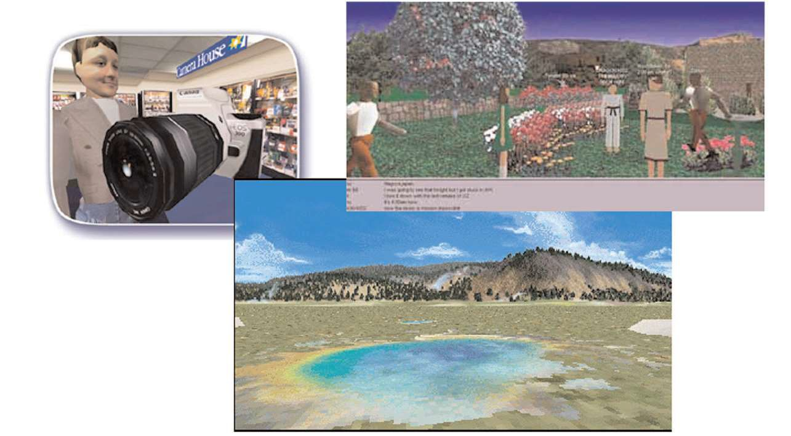

**3D Interfaces**

© 2010 Pearson Addison-Wesley. All rights reserved.

6-43

43



**3D Interfaces**

* Some designers dream about building interfaces that approach the richness of three-dimensional reality.
* Closer the interfaces to the real world, will be easier to use.
* For some computer-based tasks—such as medical imagery, architectural drawing, computer-assisted design, chemical-structure modeling, and scientific simulations—pure 3D representations are clearly helpful and have become major industries.
* Successful applications of 3D representations are game environments
* Some web-based game environments, such as **Second Life**, may involve millions of users and thousands of user-constructed "worlds," such as schools, shopping malls, or urban neighborhoods.
* Three-dimensional art and entertainment experiences, often delivered by web applications, provide another opportunity for innovative applications.

© 2010 Pearson Addison-Wesley. All rights reserved.

6-44

44



**3D Interfaces**

**Features for effective 3D:**

* Use occlusion, shadows, perspective, etc. carefully.
* Minimize number of navigation steps for users to accomplish their tasks.
* Keep text readable.
* Avoid unnecessary visual clutter, distraction, contrast shifts, and reflections.
* Simplify user movement.
* Prevent errors.
* Simplify object movement
* Organize groups of items in aligned structures to allow rapid visual search.
* Enable users to construct visual groups to support spatial recall.

© 2010 Pearson Addison-Wesley. All rights reserved.

6-45

45



**Teleoperation**

* Derives from two concepts:
  + direct manipulation in personal computers
  + process control in complex environments
* Physical operation is remote controlled
  + Surgery, power plants, chemical plants, military ops, computer- supported collaborative work
* **Teleoperation** (or remote operation) indicates operation of a system or machine at a distance.

© 2010 Pearson Addison-Wesley. All rights reserved.

6-46

46



**Teleoperation - Applications**

* Telemedicine:
  + Medical care delivered over communication links
  + Allows physicians to examine patients remotely and surgeons to carry out operations across continents.
* Telepathology
  + A pathologist examines tissue samples or body fluids under a remotely located microscope.
  + The transmitting workstation has a high resolution camera mounted on a motorized light microscope.
  + The pathologist at the receiving workstation can manipulate the microscope using a mouse or keyboard and can see a high resolution image of magnified sample.

© 2010 Pearson Addison-Wesley. All rights reserved.

6-47

47

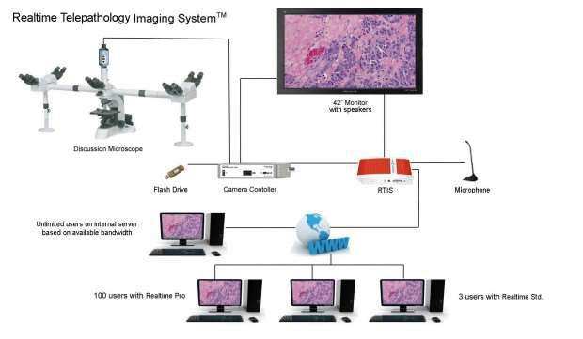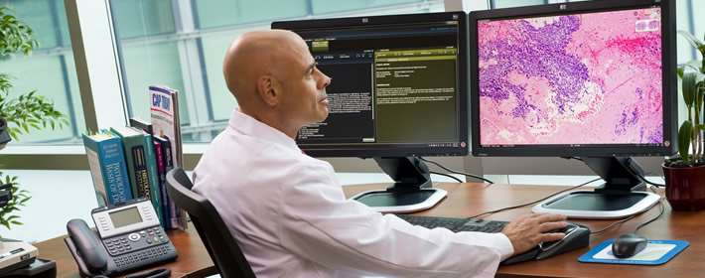

Telepathology

© 2010 Pearson Addison-Wesley. All rights reserved.

6-48

48



**Teleoperation - Applications**

* Virtual Colonoscopy:

o Allows the patient to undergo a CT scan as opposed to a more invasive procedure;

* + The physicians can then interactively navigate through a 3D model .
* Robotic surgery
  + An alternative to conventional surgery that enables a smaller incision and more accurate and precise surgical movements.

© 2010 Pearson Addison-Wesley. All rights reserved.

6-49

49

served. 6-50

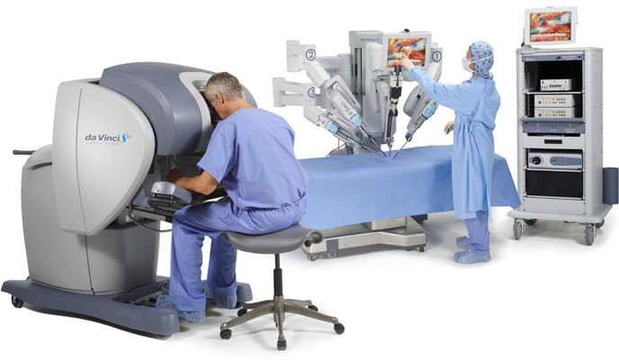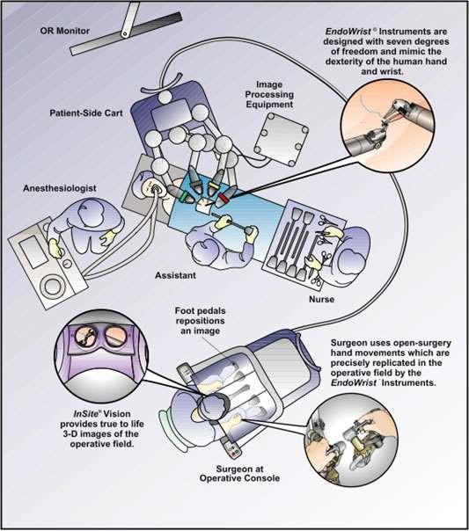

Robotic surgery

© 2010 Pearson Addison-Wesley. All rights re

50



**Teleoperation – military application**

* Commonly used by the military and by civilian space projects
* Operations using unmanned aircraft
* Teleoperated missile firing aircraft
* Agile and flexible mobile robot
* Harsh environments such as undersea, space exploration

© 2010 Pearson Addison-Wesley. All rights reserved.

6-51

51



**Teleoperation**

Complicating factors in the architecture of remote environments:

– Time delays

* transmission delays
* operation delays
* Incomplete feedback
* Feedback from multiple sources
* Unanticipated interferences

© 2010 Pearson Addison-Wesley. All rights reserved.

6-52

52



**Direct Manipulation – Benefits and Drawbacks**

**Benefits:**

* Control/display compatibility
* Less syntax reduces error rates
* Errors are more preventable
* Faster Learning and higher retention
* Encourages exploration

**Drawbacks:**

* Increased system resources
* Some action may be cumbersome
* Macro techniques are often weak
* History and other tracing may be difficult
* Visually impaired users may have more difficulty

© 2010 Pearson Addison-Wesley. All rights reserved.

6-53

53



***Designing the User Interface:***

***Strategies for Effective Human-Computer Interaction***

***Fifth Edition***

**Ben Shneiderman & Catherine Plaisant**

***in collaboration with***

**Maxine S. Cohen and Steven M. Jacobs**

**Addison Wesley**

is an imprint of

© 2010 Pearson Addison-Wesley. All rights reserved.

CHAPTER 4:

Virtual Environments

54



**Virtual Reality**

* **Virtual Reality** is a high-end user-computer interface that involves real-time simulation and interaction through multiple sensory channels.
  + Sensory information may include visual, auditory, haptic, tactile, smell, taste…
  + Visual is dominating
* Virtual reality can break physical laws and allow users to act as though they were somewhere else

© 2010 Pearson Addison-Wesley. All rights reserved.

6-55

55



**Four Key Elements in Experiencing Virtual Reality:**

1. **Virtual World**
   * An imaginary space, often (but not necessarily) manifested through a medium.
2. **Immersion**
   * Having a sense of presence within an environment; this can be purely a mental state, or can be accomplished through physical means
   * *Mental immersion* : A state of being deeply engaged, with a suspension of disbelief
   * *Physical immersion* : Bodily entering a medium
3. **Sensory feedback**
   * Visual/aural/haptic feedback to participants, based on some aspects of their physical positions
4. **Interactivity**
   * In a virtual reality experience, participants are able to move around and change their viewpoint, generally through movements of their head.

© 2010 Pearson Addison-Wesley. All rights reserved.

6-56

56



**Significance of Virtual reality in**

**Flight Simulators**

* Flight simulation designers work hard to create the most realistic experience for fighter and airline pilots.
* The cockpit displays and controls are taken from the same production line that creates the real ones.
* Then the windows are replaced by high resolution computer displays and sounds are choreographed to give the impression of engine start or reverse thrust.
* Finally the vibration and tilting during climbing or turning are created by hydraulic jacks and intricate suspension system.

© 2010 Pearson Addison-Wesley. All rights reserved.

6-57

57



**Significance of Virtual reality in**

**Flight Simulators (Cont..)**

* The elaborate technology may cost $100 million but even so, it is lot cheaper, safer, and more useful for training than the $400 million jet that it simulates.
* Flying a plane is a complicated and specialized skill, but simulators are available for more common and some surprising tasks under the alluring name of **virtual reality** or more descriptive **Virtual environments**.

© 2010 Pearson Addison-Wesley. All rights reserved.

6-58

58



**Types of VR Systems**

* Immersive VR (Artificial Reality)
* Telepresence
* Augmented reality
* Desktop reality

© 2010 Pearson Addison-Wesley. All rights reserved.

6-59

59



**Artificial reality and CAVE**

* Large screen projectors and video sensors combined full body movement with projected images of light creatures that walked along a performer’s arm or of multicolored patterns and sounds generated by the performer’s movement.
* The CAVETM ( Cave Automatic Virtual Environment), a room with several walls of high resolution rear projected displays with three-dimensional audio.
* Can offer satisfying experiences for several people at a time.
* The theoretical possibilities have attracted researchers and media pioneers who are merging reality with virtuality.

© 2010 Pearson Addison-Wesley. All rights reserved.

6-60

60

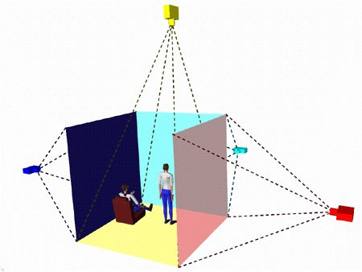

**CAVE**

© 2010 Pearson Addison-Wesley. All rights reserved.

6-61

61



**CAVE – video**

© 2010 Pearson Addison-Wesley. All rights reserved.

6-62

62

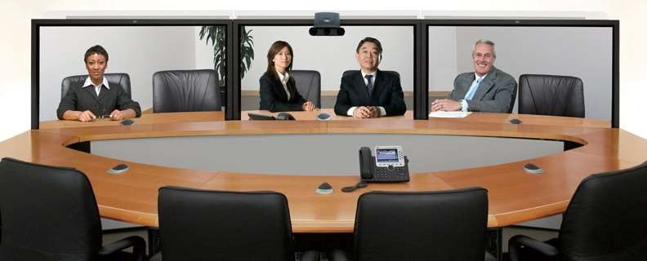

**Telepresence**

* Telepresence aspect of virtual reality break the physical limitations of space and allows users to act as though they are somewhere else.
* Telepresence is a computer-generated environment consisting of interactive simulations and computer graphics in which a human experiences presence in a remote location.
* **CISCO Telepresence Board Room: (Online video)**
* [http://video.cisco.com/#category/videos/industries](http://video.cisco.com/%23category/videos/industries)

© 2010 Pearson Addison-Wesley. All rights reserved.

6-63

63



**Augmented reality**

* Enables users to see the real world with an overlay of additional information.
* Examples:
  + while users are looking at the walls of a building, their semitransparent eyeglasses may show the location of electrical wires and studwork.
  + Medical applications, such as allowing surgeons to look at a patient while they see an overlay of an x-ray or sonogram to help locate a cancer tumor.

© 2010 Pearson Addison-Wesley. All rights reserved.

6-64

64

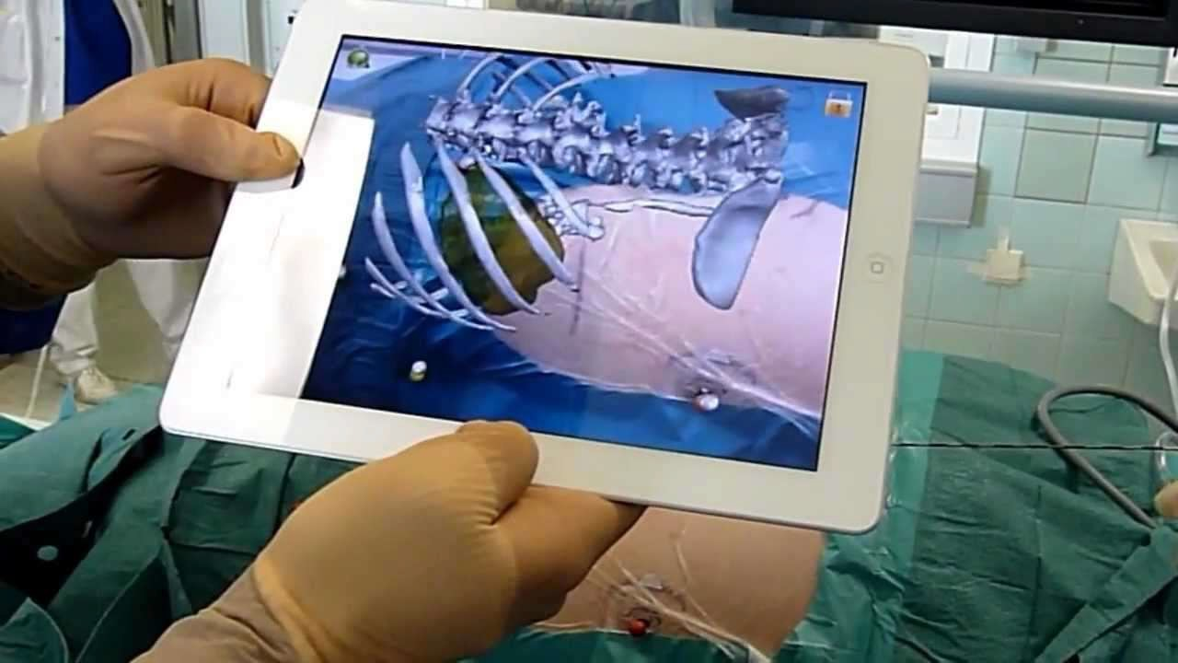

**Augmented Reality – Medical Application**

© 2010 Pearson Addison-Wesley. All rights reserved.

6-65

65



**Desktop Virtual Reality:**

* **Desktop or fish tank virtual environments** (both references are to standard "looking-at" displays) are becoming more common, because they avoid the physically distressing symptoms and require only standard equipment.
* Three-dimensional graphics have led to the development of user interfaces that support user-controlled exploration of real places, scientific visualizations, or fantasy worlds.
* Many applications run on high performance workstations capable of rapid rendering, but some are appealing even over the Web, using VRML and its successors, such as X3D.

© 2010 Pearson Addison-Wesley. All rights reserved.

6-66

66



**Technologies for**

**Successful virtual environments**

* Visual Display
* Head position sensing
* Hand-position sensing
* Force feedback & Haptics
* Sound input and output
* Other sensations
* Cooperative and competitive virtual reality

© 2010 Pearson Addison-Wesley. All rights reserved.

6-67

67

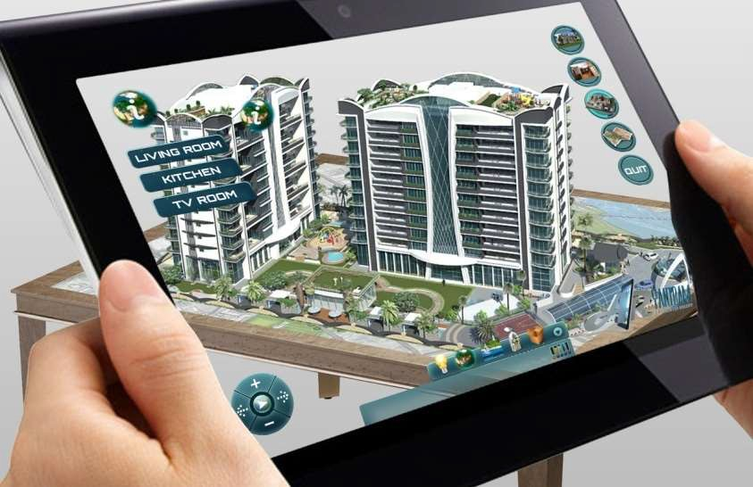

**1. Visual Display**

**Technologies for**

**Successful virtual environments**

* **Visual display.** The normal-size (12 to 17 inches diagonally) computer display at a normal viewing distance (70 centimeters) subtends an angle of about 5 degrees; large-screen (17- to 30-inch) displays can cover a 20- to 30-degree field, and head-mounted displays cover 100 degrees horizontally and 60 degrees vertically.
* **The head-mounted displays** block other images, so the effect is more dramatic, and head motion produces new images, so the users can get the impression of 360-degrce coverage. Flight simulators also block extraneous images, but they do so without forcing the users to wear sometimes- cumbersome head-mounted displays.
* Another approach is a **boom-mounted display** that senses the users' positions without requiring them to wear heavy goggles

© 2010 Pearson Addison-Wesley. All rights reserved.

6-68

68

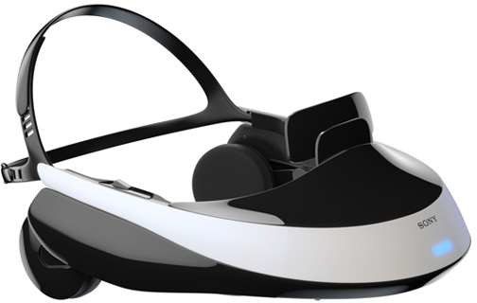

**2. Head Position sensing**

**Technologies for**

**Successful virtual environments**

* **Head-position sensing**. Head-mounted displays can provide differing views depending on head position. Look to the right, and you see a forest; look to the left, and the forest gives way to a city.
* Some head trackers can be cumbersome to wear, but smaller versions embedded in a hat or eyeglasses facilitate mobility. Video recognition of head position is possible.
* Sensor precision should be high (within 1 degree and within 1centimeter) and rapid (within 100 milliseconds).
* Eye tracking to recognize the focus of attention might be useful, but it is difficult to accomplish while the user is moving and is wearing a head- mounted display.

© 2010 Pearson Addison-Wesley. All rights reserved.

6-69

69

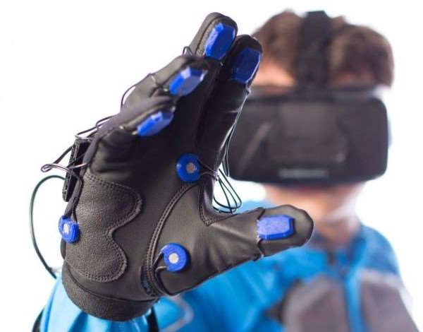

**3. Hand Position sensing**

**Technologies for**

**Successful virtual environments**

* Hand-position sensing. The DataGlove™ is an innovative invention that continues to be refined, with improvements being made to its comfort, accuracy, and sampling rate.
* The problems with glove devices include inaccuracies in measurement and lack of standard gestural vocabulary.
* It may turn out that accurate measurement of finger position is required only for one or two fingers or even one or two joints.

© 2010 Pearson Addison-Wesley. All rights reserved.

6-70

70

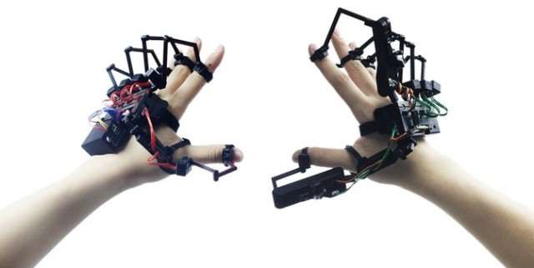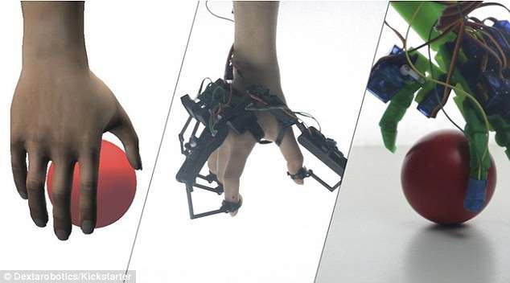

**4. Force feedback & Haptics**

**Technologies for**

**Successful virtual environments**

* Hand-operated remote-control devices for performing experiments in chemistry laboratories or for handling nuclear materials provide force feedback that gives users a good sense of when they grasp an object or bump into one.
* Force feedback to car drivers and pilots is carefully configured to provide realistic and useful tactile information. Simulated feedback from software was successful in speeding docking tasks with complex molecules.

Immersive Experience : (online video)

**Humans Fly like a Bird:**

<http://www.sciencedaily.com/videos/39ace63e5be17764fd82ee48c6a33fee.htm>

© 2010 Pearson Addison-Wesley. All rights reserved.

6-71

71

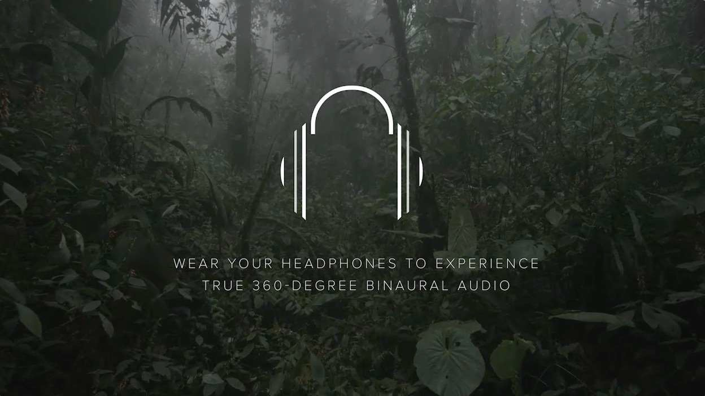

**5. Sound input & Output**

**Technologies for**

**Successful virtual environments**

* Sound output adds realism to bouncing balls, beating hearts, or dropping vases, as videogame designers found out long ago.

© 2010 Pearson Addison-Wesley. All rights reserved.

6-72

72

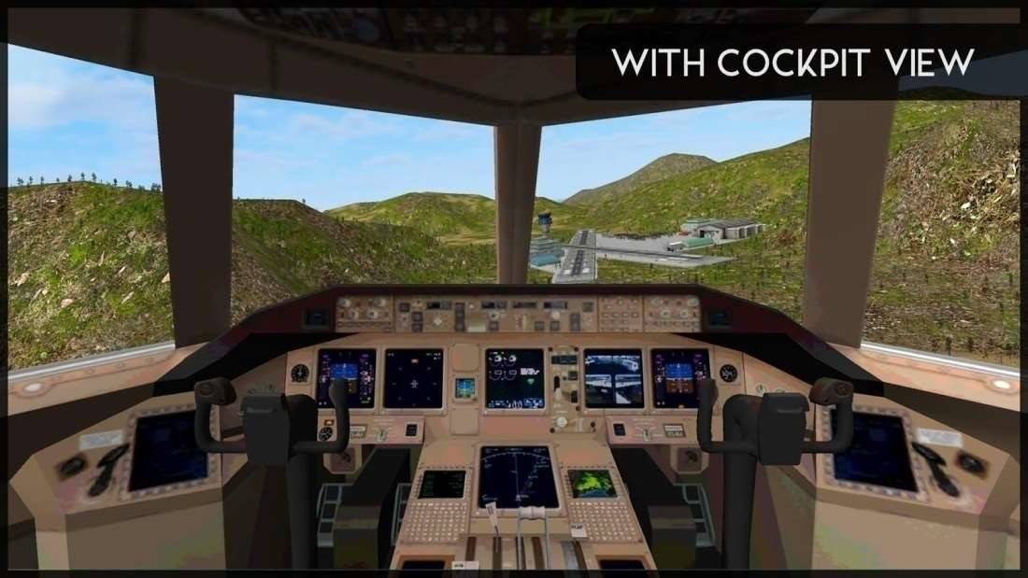

**6. Other sensations**

**Technologies for**

**Successful virtual environments**

* The tilting and vibration of flight simulators
* Tilting and Vibrating Virtual Roller Coaster

© 2010 Pearson Addison-Wesley. All rights reserved.

6-73

73

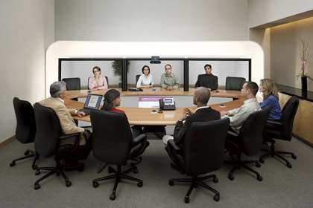

**Technologies for**

**Successful virtual environments**

**6. Collaborative Virtual Environments**

* Such environments allow two people at remote sites to work together, possibly designing an object, while seeing each other's actions and the object of interest

© 2010 Pearson Addison-Wesley. All rights reserved.

6-74

74



***Designing the User Interface:***

***Strategies for Effective Human-Computer Interaction***

***Fifth Edition***

**Ben Shneiderman & Catherine Plaisant**

***in collaboration with***

**Maxine S. Cohen and Steven M. Jacobs**

**Addison Wesley**

is an imprint of

© 2010 Pearson Addison-Wesley. All rights reserved.

CHAPTER 5:

Interaction Devices

75



**Interaction Devices**

* Keyboard Layouts
* Pointing devices
* Novel devices
* Speech & auditory interfaces
* Displays

© 2010 Pearson Addison-Wesley. All rights reserved.

8-76

76



**Speech and auditory interfaces**

* Speech recognition still a challenging one:
  + demands of user's working memory
  + background noise problematic
  + variations in user speech performance impacts effectiveness
  + most useful in specific applications, such as to benefit handicapped users

© 2010 Pearson Addison-Wesley. All rights reserved.

8-77

77

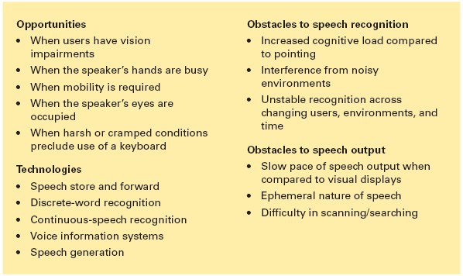

**Speech and auditory interfaces (cont.)**

© 2010 Pearson Addison-Wesley. All rights reserved.

8-78

78



**Discrete word recognition**

* Recognize individual words spoken by a specific person; can work with 90- to 98-percent reliability for 20 to 200 word vocabularies
* Speaker-dependent training, in which the user repeats the full vocabulary once or twice
* Speaker-independent systems are beginning to be reliable enough for certain commercial applications

© 2010 Pearson Addison-Wesley. All rights reserved.

8-79

79



**Continuous-speech recognition**

* **Challenges:**
  + Difficulty in recognizing boundaries between spoken words
  + Normal speech patterns blur boundaries
  + Diverse accents
  + Variable speaking rates
  + Disruptive background noise
  + Challenging emotional intonation

© 2010 Pearson Addison-Wesley. All rights reserved.

8-80

80



**Continuous-speech recognition**

**Applications of CSR systems:**

 Enable users to dictate letters and compose reports verbally for automatic transcription.

 Enable automatic scanning and retrieval from radio or television programs, court proceedings, lectures, or telephone calls for specific words or topics.

**Examples:**

 IBM ViaVoice® speech-dictation system

* Dragon® - NaturallySpeaking™ Medical system

© 2010 Pearson Addison-Wesley. All rights reserved.

8-81

81



**Voice Information System**

* **Interactive Voice Response** (IVR) – can provide good customer service at low cost.
* Voice Information technologies are used in Personal Voicemail systems.
* **Telephone based speech systems** enable storing and forwarding of spoken messages with user commands entered with keyboards. ( eg: Whatsapp)
* Small hand held **voice note-takers** available in the market.
* **Audio books** have been successful – allow users to control the pace, while conveying the curator’s enthusiasm or author’s emotions.

© 2010 Pearson Addison-Wesley. All rights reserved.

8-82

82



**Speech generation**

* Speech generation is a successful technology:
  + Inexpensive, compact and reliable systems using digitized speech segments have been used in Automobile Navigation System, Internet services, Utility Control rooms and Children's games.
* Applications for Blind:
  + Text-to-speech utilities like the built-in **Microsoft Windows Narrator.**
  + Screen readers like **Freedom Scientific’s JAWS** – allows users with visual impairments to productively navigate between windows, select applications, browse graphical interfaces and read text

© 2010 Pearson Addison-Wesley. All rights reserved.

8-83

83



**Speech Generation**

**Speech Synthesis:**

* **Speech synthesis** is technologically feasible. Algorithms are used to generate the sound (**speech synthesis**) and the intonation may sound robot-like and distracting.
* The quality of the sound can be improved when phonemes, words, and phrases from digitized human speech can be smoothly integrated into meaningful sentences.
* However, for some applications, a computer-like sound may be preferred. For example, the robot-like sounds used in the Atlanta airport subway drew more attention than did a tape recording of a human giving directions.

© 2010 Pearson Addison-Wesley. All rights reserved.

8-84

84



**Speech Generation**

**Web-based voice applications:**

* Web-based voice applications are also seen as promising by many developers.
* Standards for voice tagging of web pages (VoiceXML™and Speech Application Language Tags, or SALT) and improved software could enable several innovative applications.
* For example, cell-phone users could access web information through combinations of visual displays and speech-generation output.

© 2010 Pearson Addison-Wesley. All rights reserved.

8-85

85



**Displays – Small and Large**

* The display has become the primary source of feedback to the user from the computer
* The display has many important characteristics, including:
  + **Physical dimensions** (usually the diagonal dimension and depth)
  + **Resolution** (the number of pixels available)
  + **Number of available colors, color correctness**
  + **Luminance, contrast, and glare**
  + **Power consumption**
  + **Refresh rates** (sufficient to allow animation and video)
  + **Cost**
  + **Reliability**

© 2010 Pearson Addison-Wesley. All rights reserved.

8-86

86

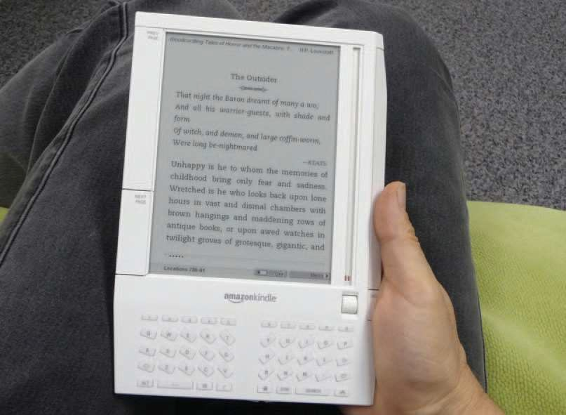

**Displays – Small and Large (cont.)**

**Usage characteristics** distinguish displays:

* **Portability**
* **Privacy**
* **Saliency**
* **Ubiquity**
* **Simultaneity**

© 2010 Pearson Addison-Wesley. All rights reserved.

8-87

87



**Display technology**

* Raster-scan cathode-ray tube (CRT)

–

–

–

–

–

–

electron beam sweeping out lines of dots to form letters refresh rates 30 to 70 per second

Liquid-crystal displays (LCDs)

voltage changes influence the polarization of tiny capsules of liquid crystals

Thin film, light weight, low electricity consumption

Plasma Displays

rows of horizontal wires are slightly separated from vertical wires by small glass-enclosed capsules of neon-based gases

Flat profile, consume more electricity

© 2010 Pearson Addison-Wesley. All rights reserved.

8-88

88



**Display technology (cont.)**

* **Light-emitting diodes (LEDs)**
  + certain diodes emit light when a voltage is applied
  + arrays of these small diodes can be assembled to display characters
  + Used in large public displays, curved displays
  + Matrices of some miniature LEDs are also used in some head- mounted displays.
* **Organic Light-emitting diodes (OLEDs)**
  + Durable & energy efficient
  + Laid on flexible plastic or metallic foil
  + Used with wearable or rollable displays

© 2010 Pearson Addison-Wesley. All rights reserved.

8-89

89

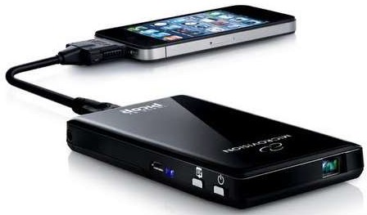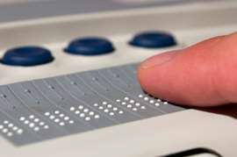

**Display technology (cont.)**

* **Electronic ink technology**
  + Paper-like resolution

– Tiny capsules with negatively charged black particles and positively charged white particles can be selectively made visible.

* **Tiny Projectors –** Microvision Pico projectors – Project color images on the wall from

mobile devices

* **Braille displays**
  + for the blind users

© 2010 Pearson Addison-Wesley. All rights reserved.

8-90

90



**Large Displays**

* Informational wall displays
* Interactive wall displays
* Multiple desktop displays

© 2010 Pearson Addison-Wesley. All rights reserved.

8-91

91

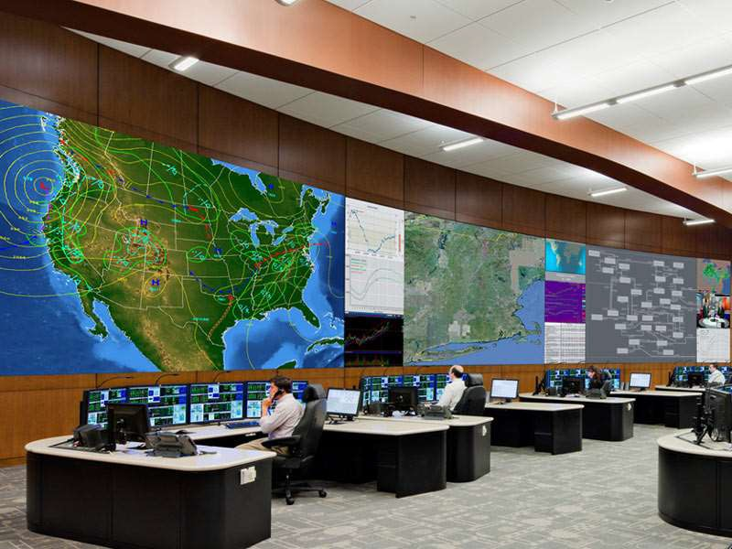

**Large Displays**

© 2010 Pearson Addison-Wesley. All rights reserved.

8-92

92

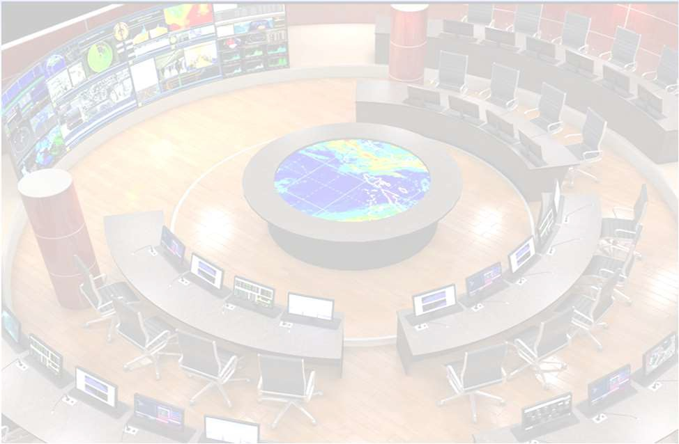

**Large Informational Wall Displays**

•

•

•

o o o

o

Effective in Control rooms

Details can be retrieved on individual consoles Applications:

Military command and control operations Utility Management

Emergency response

Allows teams of collaborating scientists and decision makers

© 2010 Pearson Addison-Wesley. All rights reserved.

8-93

93

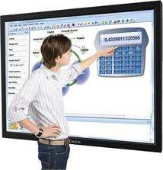

**Interactive Wall Displays**

* Large touch sensitive screen on which a computer screen is projected
* Digital white board System:
  + SMART Board® from SMART technologies Inc.
  + Colored pens and digital eraser simulate a traditional white board
  + Facilitates Screen recording and software keyboard

© 2010 Pearson Addison-Wesley. All rights reserved.

8-94

94



**Multiple Desktop Displays**

* Discontinuities in the overall display space
* Can be of different size and resolution
* Users to stand or rotate their heads or bodies to attend all displays
* Useful for personal creative applications
* **Example:** Flash application might require a timeline, a stage, graphic component editors, a scripting language editor, a directory browser and a preview window, all open at the same

© 2010 Pearson Addison-Wesley. All rights reserved.

95

8-95

time.

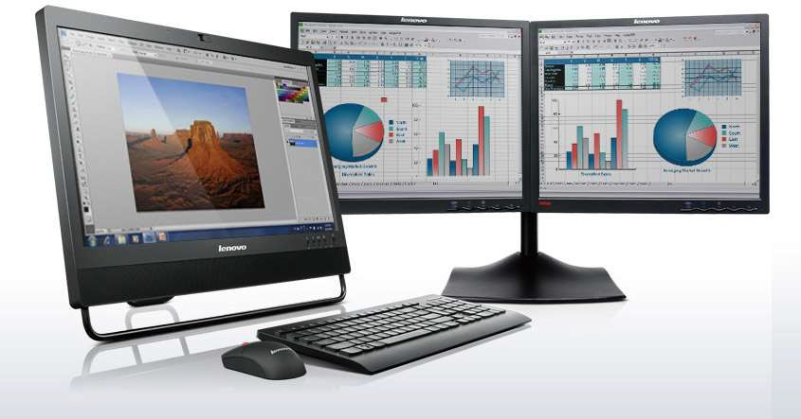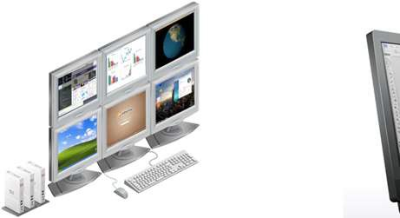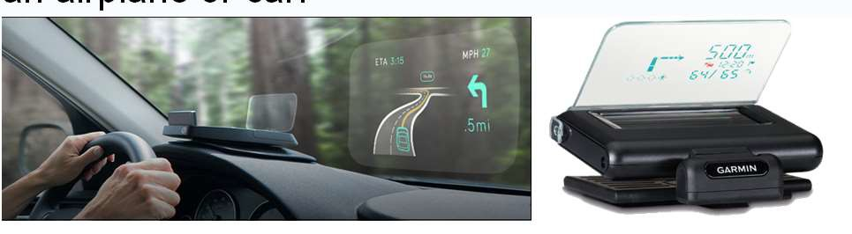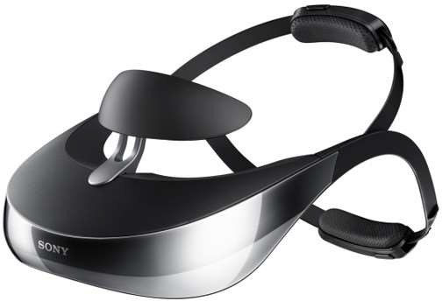

**Heads-up and helmet mounted displays**

* A heads-up display can, for instance, project information on a partially silvered widescreen of an airplane or car.
* A helmet/head mounted display (HMD) moves the image with the user.
* 3D images

© 2010 Pearson Addison-Wesley. All rights reserved.

8-96

96

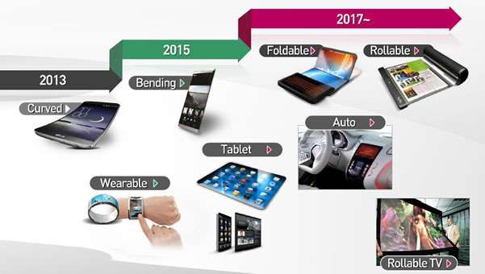

**Mobile device displays**

* Currently mobile devices used for brief tasks, except for game playing
* Optimize for repetitive tasks
* Custom designs to take advantage of every pixel
* DataLens allows compact overviews
* Web browsing difficult
* Okay for linear reading, but making comparisons can be difficult

© 2010 Pearson Addison-Wesley. All rights reserved.

8-97

97



***Designing the User Interface:***

***Strategies for Effective Human-Computer Interaction***

***Fifth Edition***

**Ben Shneiderman & Catherine Plaisant**

***in collaboration with***

**Maxine S. Cohen and Steven M. Jacobs**

**Addison Wesley**

is an imprint of

© 2010 Pearson Addison-Wesley. All rights reserved.

**CHAPTER 6:**

**Information Visualization**

98



**Information Visualization**

**“A Picture is worth a thousand words”**

* **Introduction**
* **Data Type by Task Taxonomy**
* **Challenges for Information Visualization**

© 2010 Pearson Addison-Wesley. All rights reserved.

14-99

99



**Introduction**

* Information visualization can be defined as the use of interactive visual representations of abstract data to amplify cognition
* Information visualization provides compact graphical presentations and user interfaces for interactively manipulating large numbers of items, possibly extracted from far larger datasets.
* The abstract characteristic of the data is what distinguishes information visualization from scientific visualization.
  + Information visualization: categorical variables and the discovery of patterns, trends, clusters, outliers, and gaps
  + Scientific visualization: continuous variables, volumes and surfaces

© 2010 Pearson Addison-Wesley. All rights reserved.

14-100

100



**Introduction**

* Sometimes called visual data mining, it uses the enormous visual bandwidth and the remarkable human perceptual system to enable users to make discoveries, make decisions, or propose explanations about patterns, groups of items, or individual items.
* Visual-information-seeking mantra:
  + Overview first, zoom and filter, then details on demand.
  + Overview first, zoom and filter, then details on demand.
  + Overview first, zoom and filter, then details on demand.

© 2010 Pearson Addison-Wesley. All rights reserved.

14-101

101

Wesley. All rights reserved.

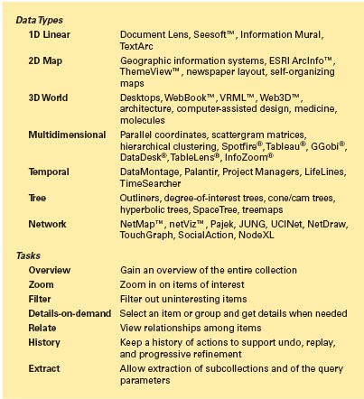

**Data Type by Task Taxonomy**

**7**

**7**

© 2010 Pearson Addison-

14-102

102

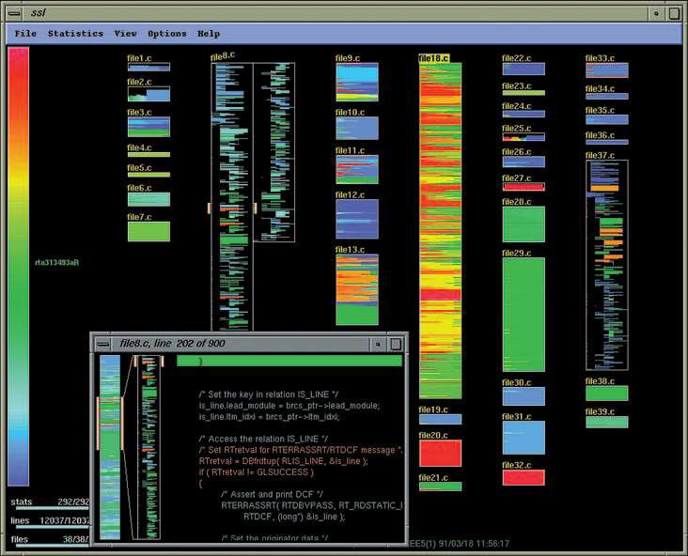

**Data Type: 1D Linear Data**

* **source code**
* **text**
* **dictionaries**
* **lists**
* **show attributes of items**

© 2010 Pearson Addison-Wesley. All rights reserved.

(Showing age of code)

14-103

103

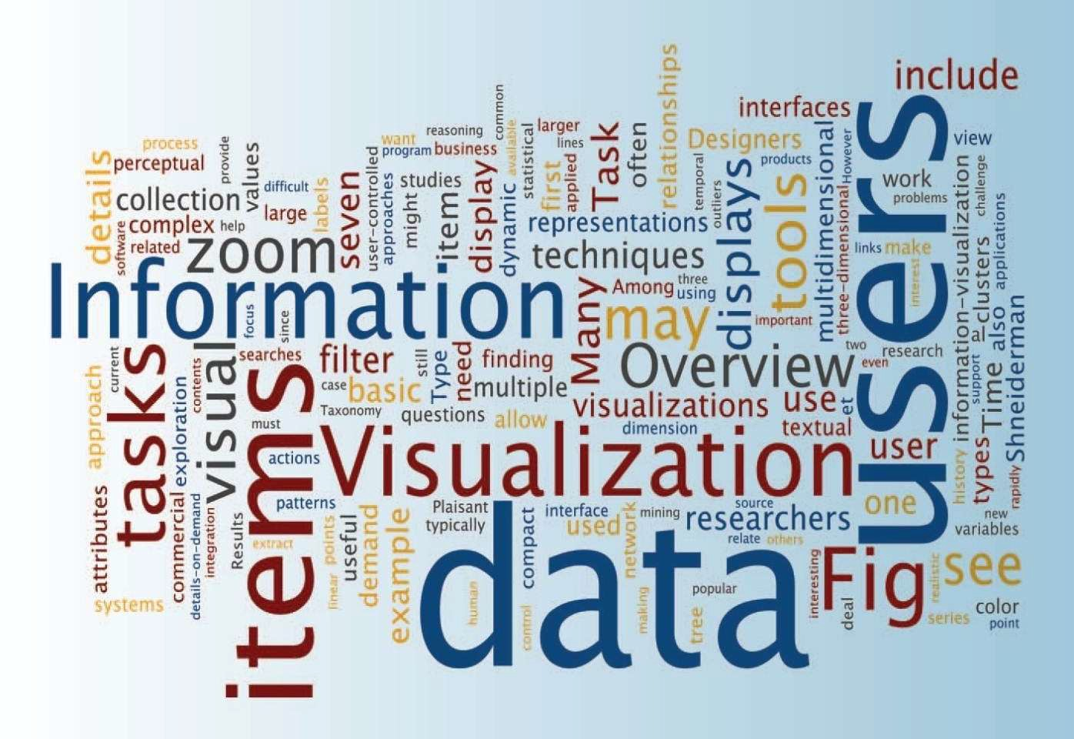

**Data Type : 1D Linear Data**

<http://www.wordle.net/>

© 2010 Pearson Addison-Wesley. All rights reserved.

(Most frequent words are larger - Wordle)

14-104

104

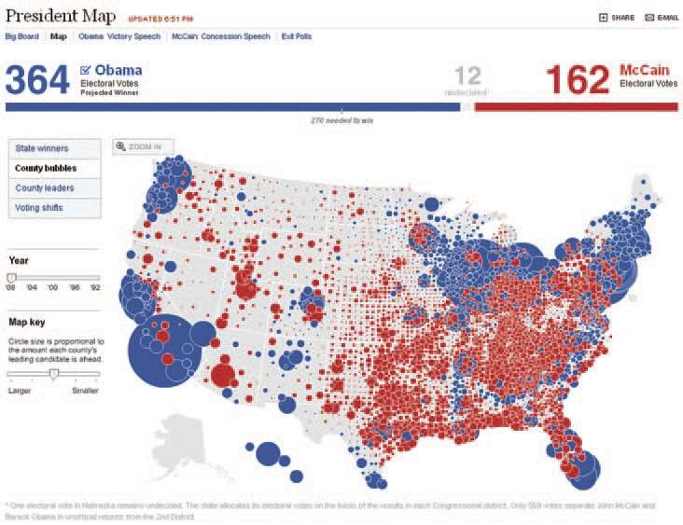

**Data Type: 2D Map Data**

* **Planar data**
* **maps**
* **floor plans**
* **news layouts**
* **may or may not be rectangular**
* **find adjacent items, regions, paths**
* **perform 7 basic tasks**

© 2010 Pearson Addison-Wesley. All rights reserved.

14-105

105

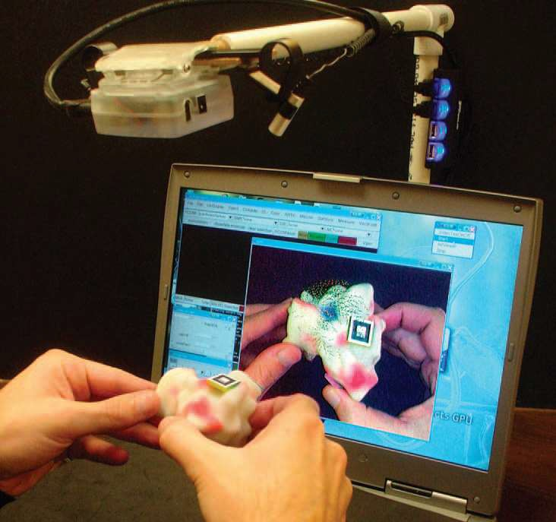

**Data Type: 3D World Data**

* Real world objects
* 3D relationships
* Must cope with orientation when viewing
* Uses: medical imaging, architectural walkthroughs

© 2010 Pearson Addison-Wesley. All rights reserved.

14-106

106

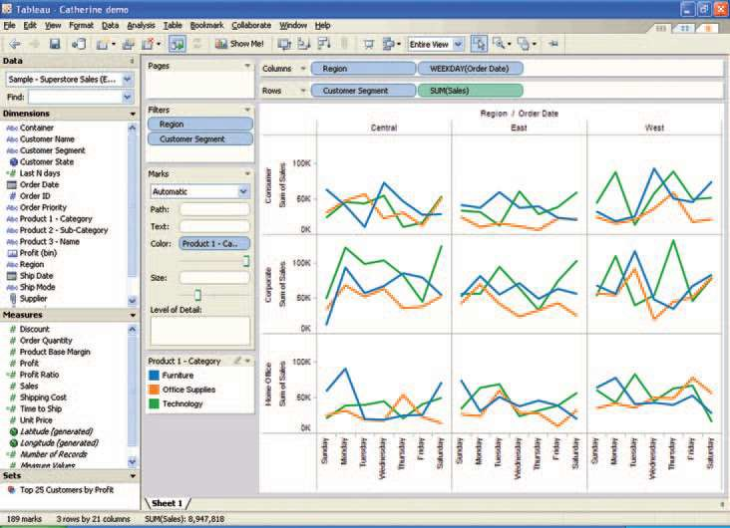

**Data Type: Multidimensional Data**

**Items with n attributes**

**EEG brain waves**

**(freq x time x channel)**

**Usually looking for patterns**

* Sales for 3 regions and 3 customer

© 2010 Pearson Addison-Wesley. All rights reserved. segments over time

14-107

107

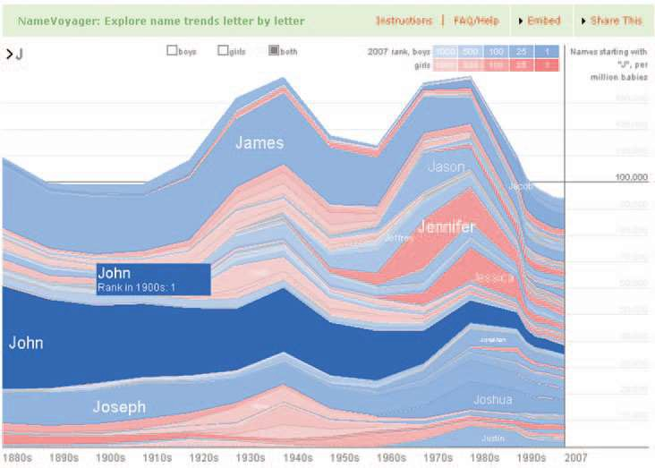

**Data Type: Temporal Data** <http://www.babynamewizard.com/voyager/>

**Time Series Data**

**EKGs,**

**Stock Market Weather**

**Have start/end times**

**items may overlap**

**compare periodical data**

© 2010 Pearson Addison-Wesley. All rights reserved.

(Trends in baby names starting with J )

14-108

108

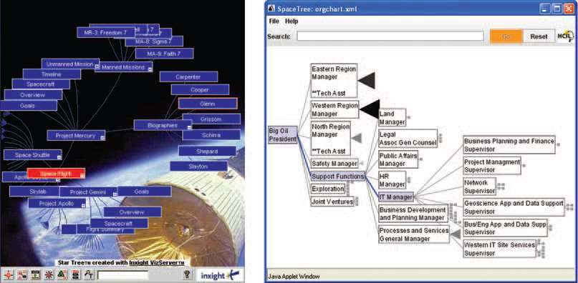

**Data Type: Tree Data**

(Two representations of same data) Hyperbolic tree

Tree

Animated

Branches smaller in periphery

© 2010 Pearson Addison-Wesley. All rights reserved.

Icon shows branches that cannot be displayed (by size)

14-109

109

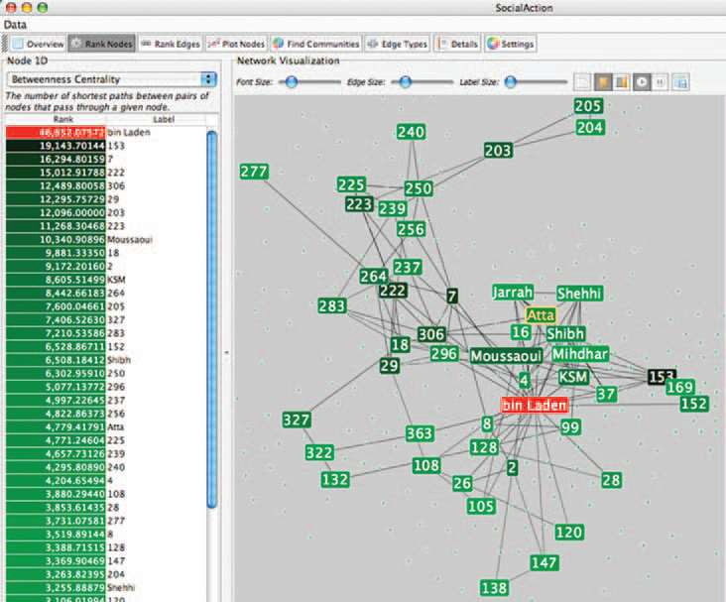

**Data Type: Network Data**

**Answers questions about paths**

**view complex relationships, such as social networks of terrorists**

© 2010 Pearson Addison-Wesley. All rights reserved.

14-110

110



**The seven basic tasks**

1. **Overview task - users can gain an overview of the entire collection**
2. **Zoom task - users can zoom in on items of interest**
3. **Filter task - users can filter out uninteresting items**
4. **Details-on-demand task - users can select an item or group to get details**
5. **Relate task - users can relate items or groups within the collection**
6. **History task - users can keep a history of actions to support undo, replay, and progressive refinement**
7. **Extract task - users can allow extraction of sub- collections and of the query parameters**

© 2010 Pearson Addison-Wesley. All rights reserved.

14-111

111



**The seven basic tasks**

**1.**

**1D Linear**

**1. Overview task**

**2.**

**2D Map**

**2. Zoom**

**3.**

**3D World**

**3. Filter task**

**4.**

**Multi-Dim**

**4. Details-on-demand task**

**5.**

**Temporal**

**5. Relate task**

**6.**

**Tree**

**6. History task**

**7.**

**Network**

**7. Extract task**

© 2010 Pearson Addison-Wesley. All rights reserved.

14-112

112



**Challenges for Information Visualization**

* **Importing and cleaning data :** preprocessing
* **Combining visual representations with textual labels**
* **Finding related information** (and integrating it)
* **Viewing large volumes of data**
* **Integrating data mining** (letting statistical analysis see subtle trends)
* **Integrating with analytical reasoning techniques**
* **Collaborating with others**
* **Achieving universal usability with visualization tools**
* **Evaluation**

© 2010 Pearson Addison-Wesley. All rights reserved.

14-113

113



**Summary**

* Information visualization

– labs→ commercial applications

* New tools available – need to be integrated smoothly with exiting software
* Need to support full task list
* Need to present information rapidly and allow user- controlled exploration
* Need advanced data structures, high-resolution color displays, fast data retrieval, and novel ways to train users
* Careful testing to ensure they actually help users perform tasks.

© 2010 Pearson Addison-Wesley. All rights reserved.

14-114

114